Perfect Policy Quiz
(Java 2 Assignment)

Student: Oktay Turdu
Date: 27/05/2022

Unit: ICTPRG523
Teacher: Mark O’Reilly

Contents

IPO Chart 3
TOE Chart 5
Selected Pseudo Code 6
ReadFile 6
SearchTable 6
HashBinary 6
SendDataToQuestionTable 7
InOrderTraverseTree 7
postOrderTraverseTree 7
Class diagram 8
Testing 9
Test Plan 9
Test Cases: 10
Evidence of Debugging 19
User Manual for: Perfect Policy Quiz (Server & Client) 22
Evidence of correspondence with your Manager and Client 26

IPO Chart

Input | Process | Output | Storage
‘Reads’ (entries) from the data file:  - Question Number  - Topic  - Subtopic  - Question  - Option 1  - Option 2  - Option 3  - Option 4  - Option 5  - Correct Answer | - Open the file  - Read all entries line by line  - Insert and save entries in application | - Show table of entries on screen | Data File  Temporary storage in RAM memory
- Sort by buttons  - will sort by Qn#, Topic, or SubTopic depending on button pressed. | - Table is cleared  - Array of entries is sent to sorting algorithm  - Array is sorted  - Array is sent back to table | Sorted Table depending on button pressed | Sorted records temporarily stored in RAM memory
- Search Topic with entered string | - Go through the table records until string matches any entry | - Table is filtered to display only one entry
- Display buttons  (Pre-Order, In-Order, Post-Order) | - Depending on sorting algorithm, binary tree is sorted | Present the sorted binary tree in binary tree text field | Sorted records stored in RAM memory where binary tree exists
- Save button | - Save all the entries in RAM Memory into the specified output file with hashing algorithm | Export of all records (entries) in table | All entries saved in a new copy of the data file.
- Exit button | - Close client or server application safely | Application is closed
- Connect button | - Connects to clients | Threads and Sockets are set and opened | Data relating to connections is stored in RAM
- Send button | - Sends data in linked list to clients |  | Data is stored on clients’ RAM
- Submit button | - Sends data back to server and records answer, server determines if answer is correct or not and records as necessary in linked list | Server records answer | Determination of answer is recorded in linked list

TOE Chart

Task | Object | Event
Load ArrayList Data | Form | Open
Send Data to Right Table and to Binary Tree and Linked List | Table | Click
Search and Filter Table | Search Topic field | Insert Text
Sort Table by Qn# | Qn # button | Click
Sort Table by Topic# | Topic button | Click
Sort Table by Subtopic# | SubTopic button | Click
Sort binary tree in post-order algorithm | Display button | Click
Sort binary tree in pre-order algorithm | Display button | Click
Hash Binary Tree and save hashed text file | Save button | Click
Close connections and exit application | Exit button | Click
Sort binary tree in in-order algorithm | Display button | Click
Send quiz and connect to client | Connect button | Click
Submit answer to server  Exit quiz | Submit button  Exit button | Click  Click

Selected Pseudo Code

ReadFile

Try
While there is data continue reading file
If 10 elements are read
Assign 10 elements to temporary array
Add temporary array to table Array
Create a new line array for more reading

Assign table Array to mainTable Array
Catch
Read errors and print failed to read file

SearchTable

Set Row Sorter to Table
Add Document Listener to Search Text Field
Search Filed is Updated
If search field is empty
Filter is set to null
Else
Table is filtered in regard to input text
Remove Text from Search Field
If search field is empty
Filter is set to null
Else
Table is filtered in regard to input text
Changed Update
Throw exception Error

HashBinary

Try
Create new Hash File
Assign Hashfile to File Output
Assign File Output to Object Output
Write Object Output to HashMap Object
Catch
Error writing hash file

SendDataToQuestionTable

ClearTable
Grab RowID of selected table object
Assign object properties to properties of table
Assign Data in object to display table

InOrderTraverseTree

If Focus Node is not null
Focus node is the left child
Temp node equals temp node plus the focus node
Add focus node to node Array
Focus node is the right child

postOrderTraverseTree

If Focus Node is not null
Focus node is the left child
Focus node is the right child
Temp node equals temp node plus the focus node

Class diagram
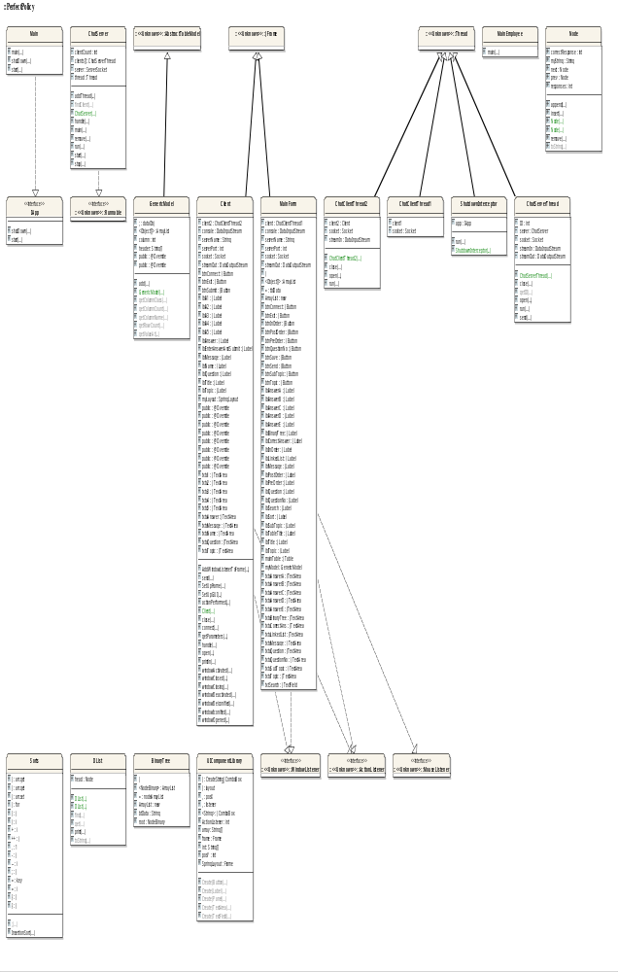

Testing

Test Plan

The approach to testing that will be used is as follows:

- Review the project requirements
- Prepare a solution design
- Develop the required application.
- Unit testing – test each component (method / class) as it is being developed
- Integrated Testing - Prepare a set of data (test cases) to check how the application will behave when appropriate data is read in and entered via the screen.
- Prepare several sets of data (test cases) to check how the application will behave when data that will generate exceptions is read in from the data file.
- Enter several sets of data (test cases) to check how the application will behave when data that will generate exceptions is entered via the screen.
- System Testing – Deploy the application to a computer system / network / web host site similar to that of the client’s and retest selected test cases.
- Acceptance Testing - Deploy the application to the client’s computer system / network / web host site and look to the client to retest using sample live data.
- Archive the test plan, test cases and results to an appropriate backup location.

Test Cases:
How I tested the connection between the client and user:

Case 1: Sending questions to user from client.

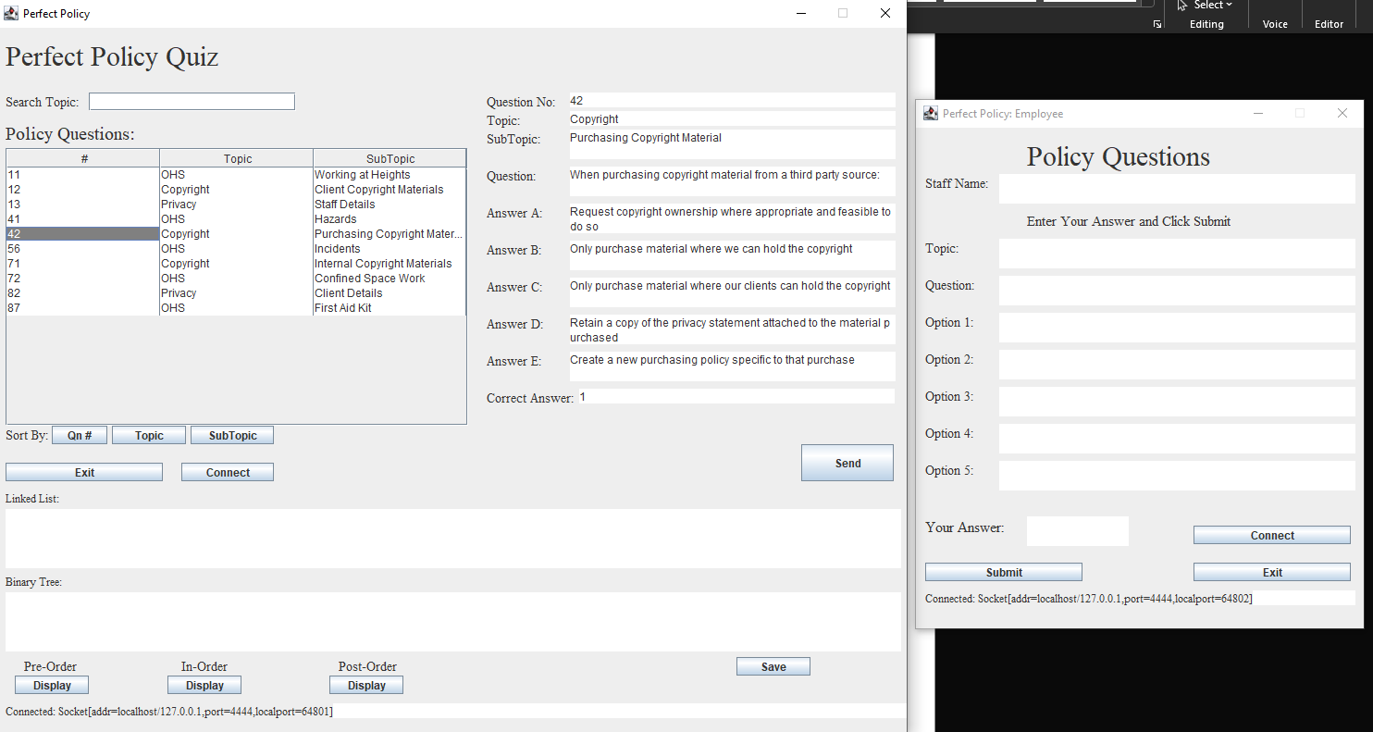

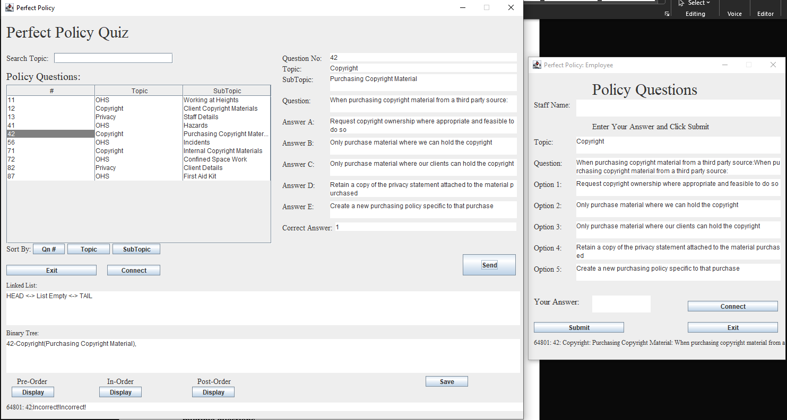
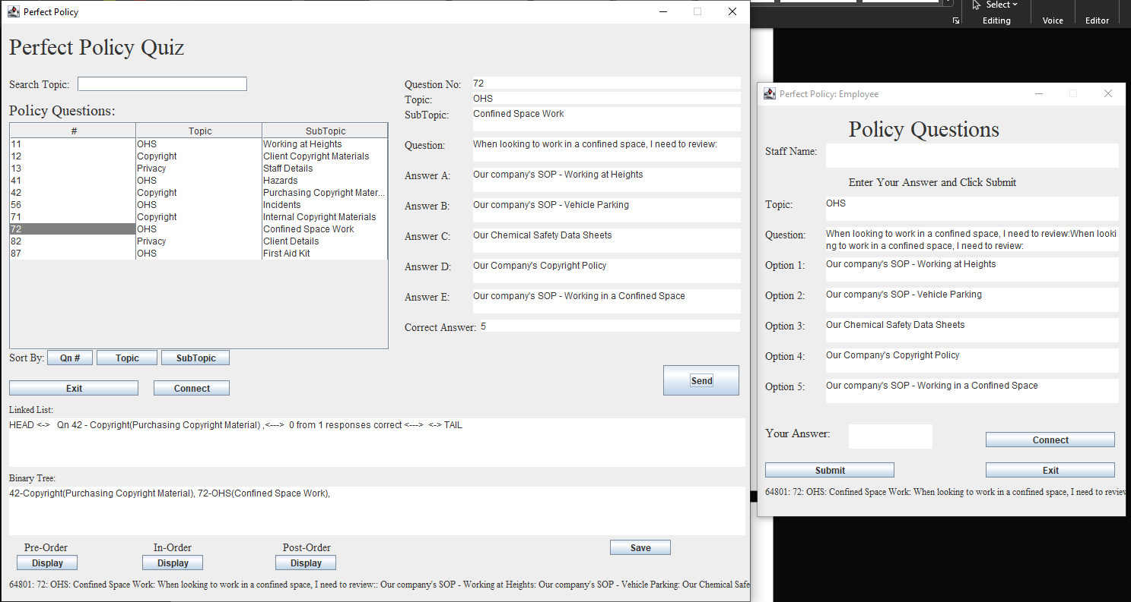

No Issues Noted.

Case 2: Sending one answer from user to client.

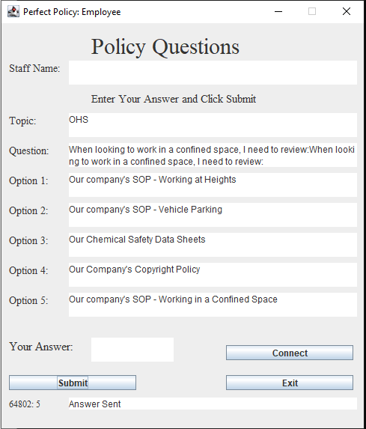

No Issues Noted

Case 3: Sending multiple answers from the same user to client for the same question.

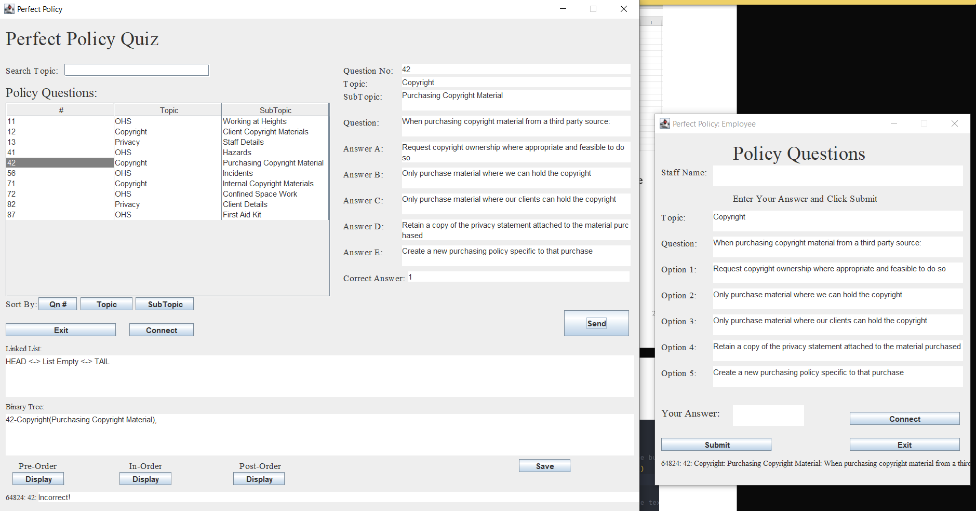

Bug: Despite being the same user, multiple inputs were recorded from the same user.

Possible Fix: Disable Submit button for user after submitting the answer once, and renable button when client sends another question.

Case 4: Sending multiple answers from the same user to client for multiple questions.

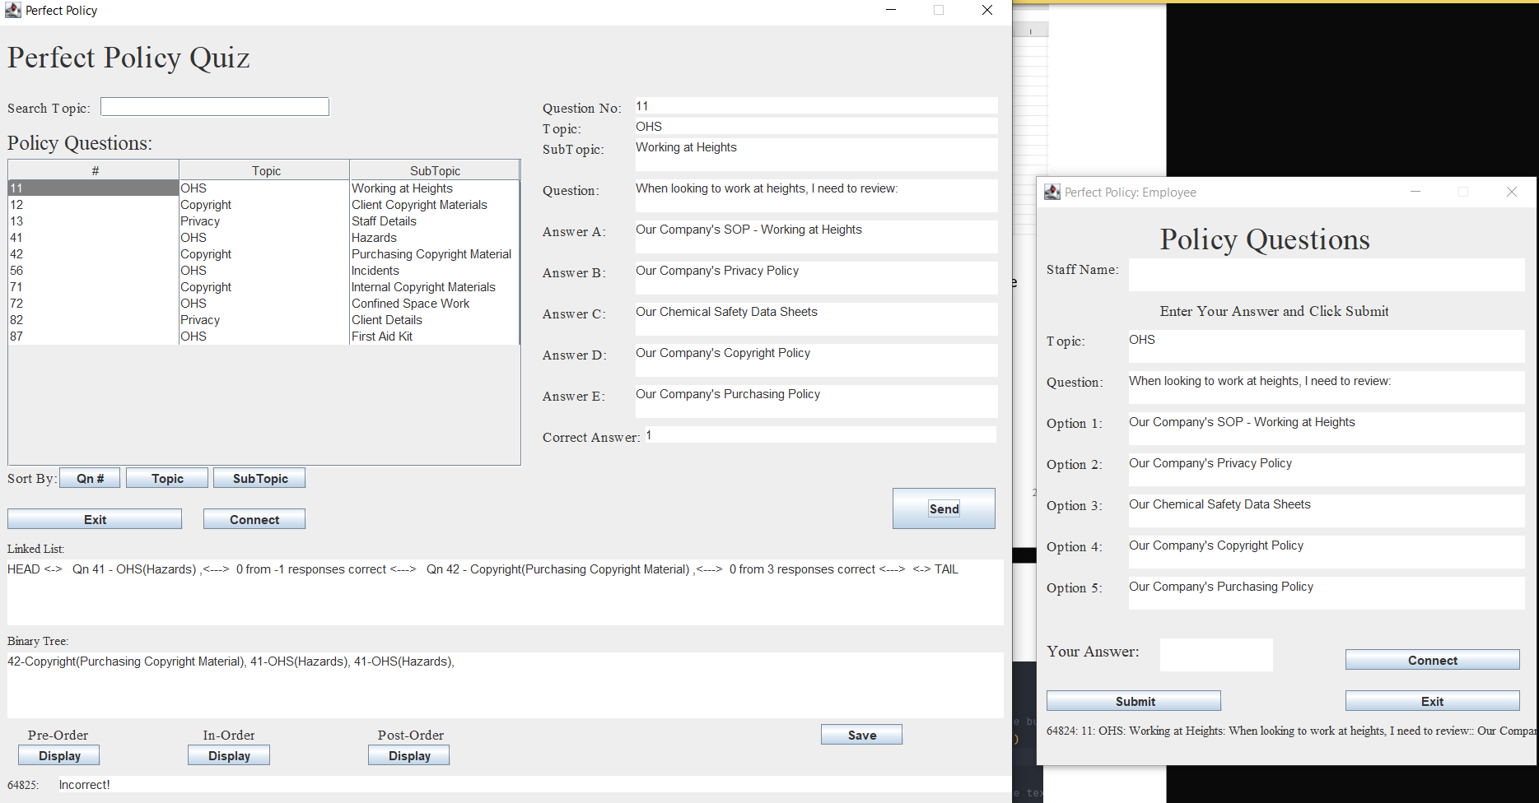

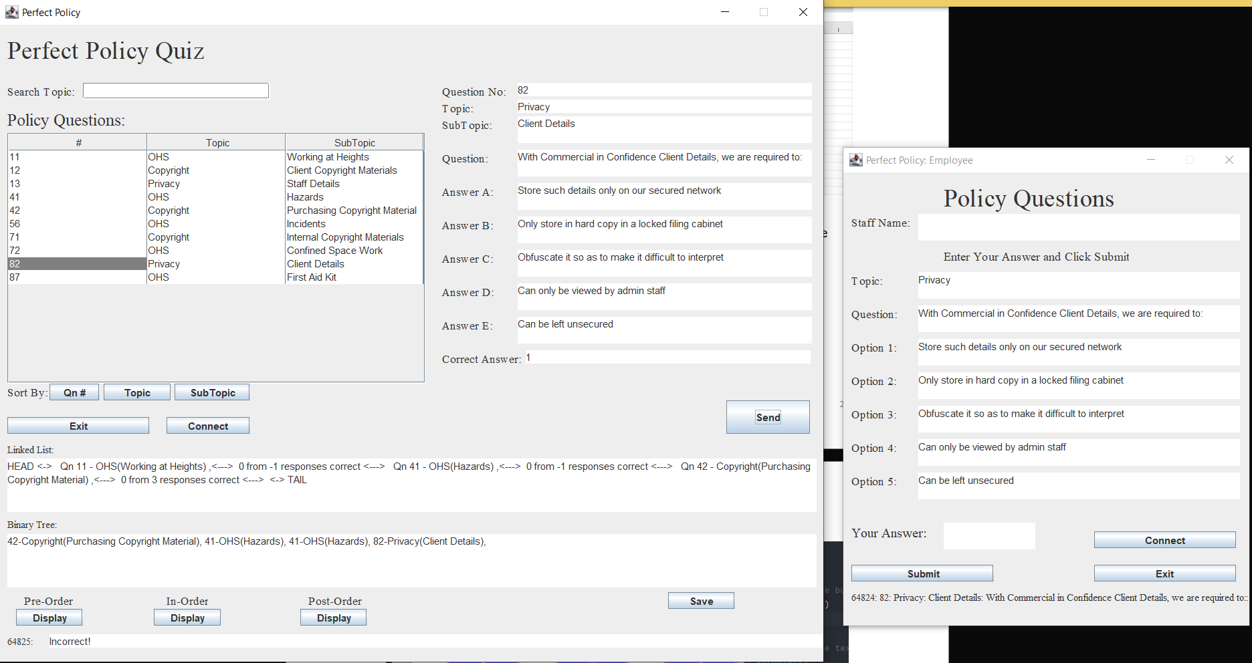

No Issues Noted

How I tested the Sort and Search functionalities:

Case 1: Sorting by Question #

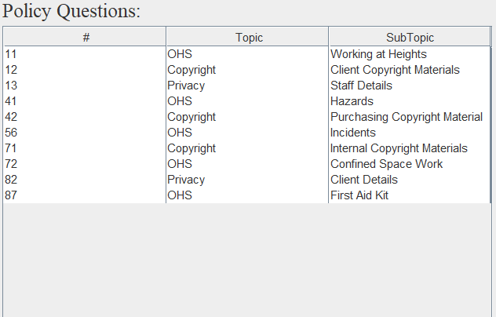

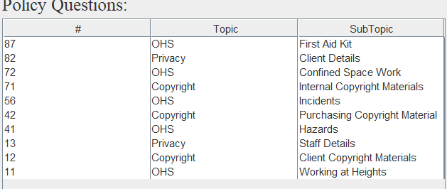

No Issues Noted

Case 2: Sorting by Question Topic

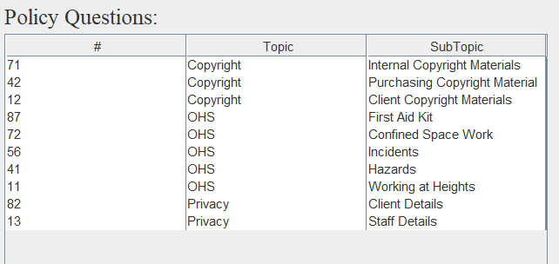

No Issues Noted

Case 3: Sorting by Question SubTopic

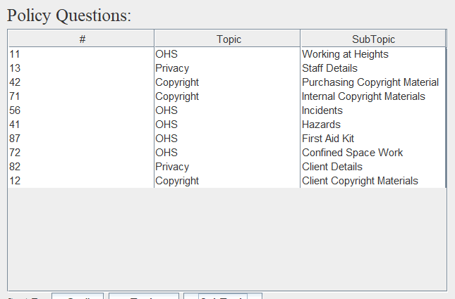

No Issues Noted

Case 4: Sorting Binary Tree in Post-Order, Pre-Order, In-Order

No Issues Noted

Case 5: Sorting Empty Binary Tree

No Issues Noted, however, a message stating that the binary tree is empty that appears in the message box below is recommended for later iterations as a way to notify the user.

Case 6: Searching Table

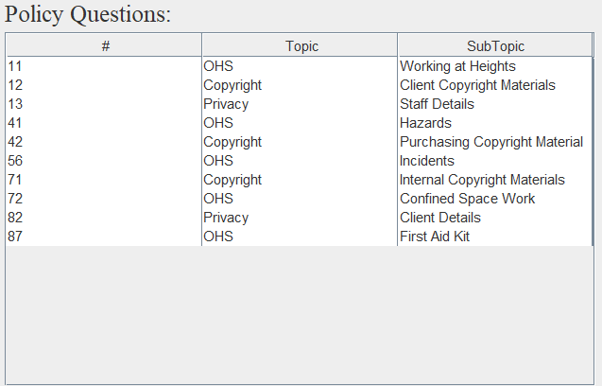
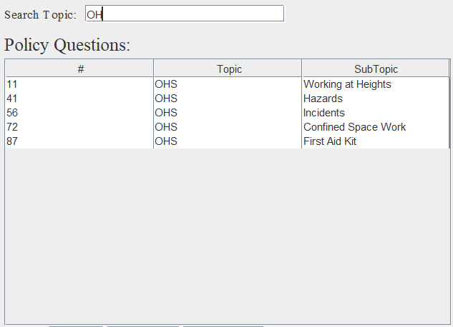

No Issues Noted

How I tested the Saving functionality:

Case 1: Saving File

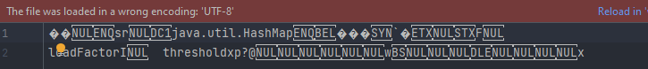

No Issues Noted

Results of testing:

Overall, the application can be improved through several minor bug fixes that check for inputs properly. If input is incorrect a dialogue window could open to communicate to the user explaining what they did wrong instead of simply doing nothing or performing a function logically incorrect.

Evidence of Debugging

Two to three screen images demonstrating debugging:

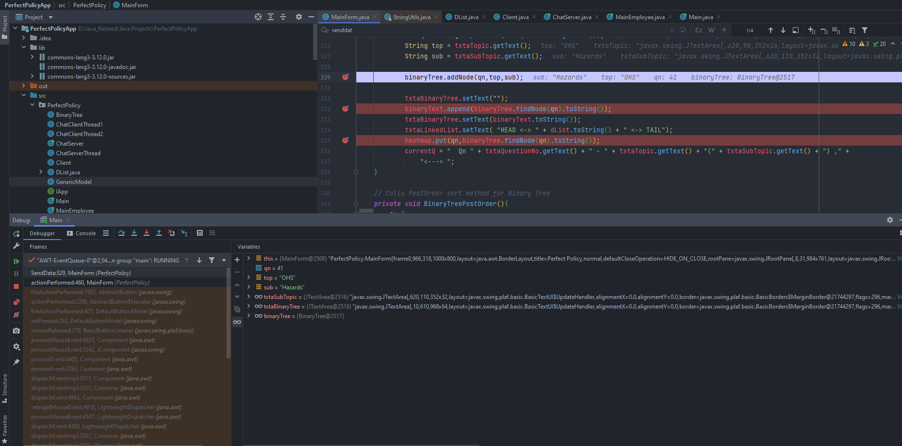

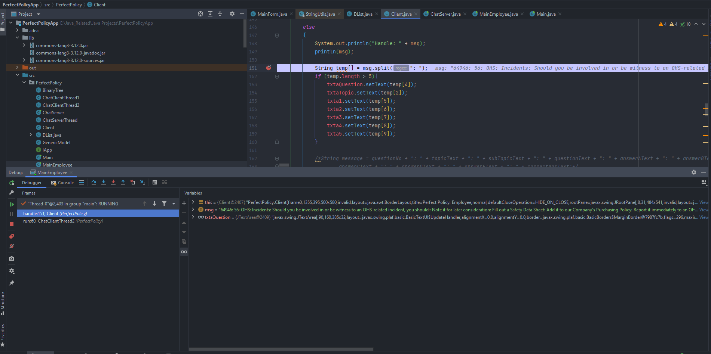

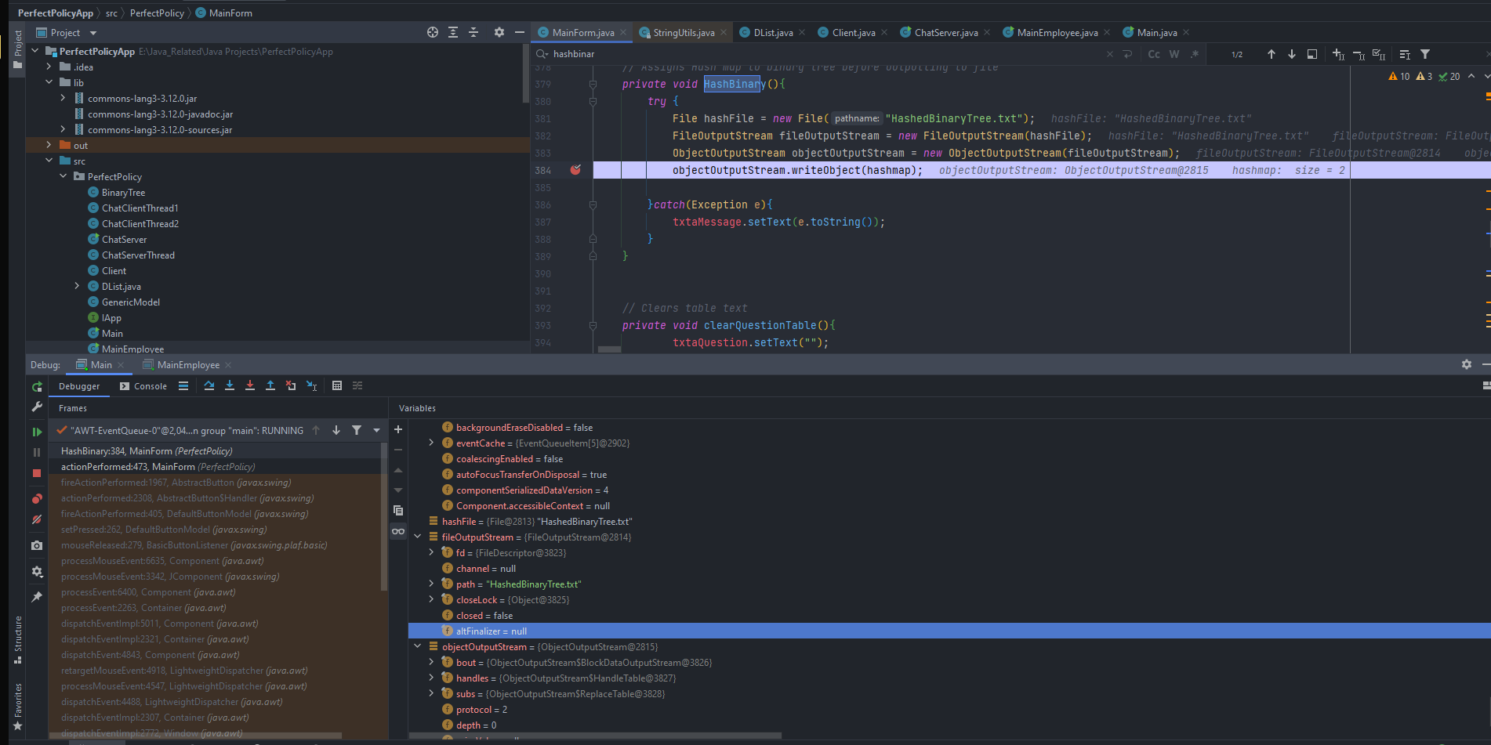

User Manual for: Perfect Policy Quiz (Server & Client)
Prepared for: Perfect Policies
Author: Oktay Turdu
Date Prepared: 27/05/2022

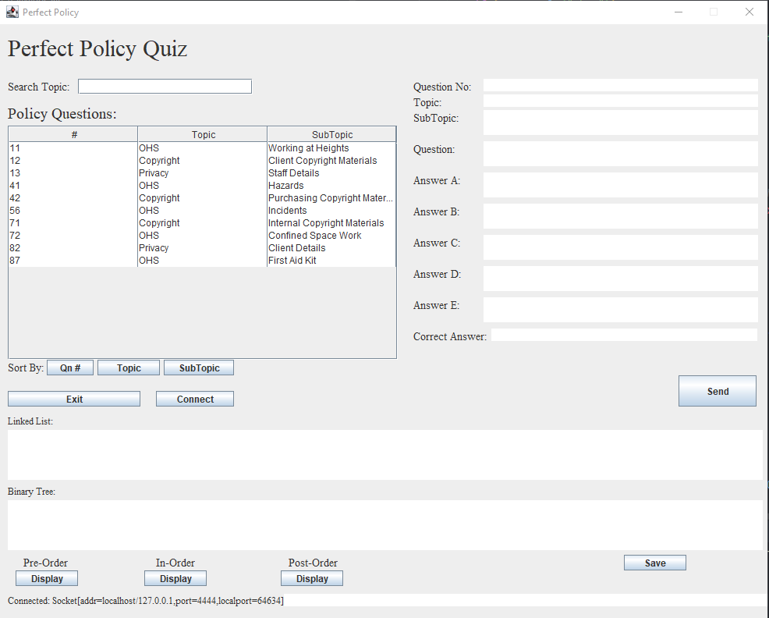 | Features by Component/Button  Screen opens: Load Policy Questions text file  Qn # button: Sorts table above in accordance with Question Numbers.  Topic button: Sorts table above in accordance with Question Topic  Subtopic button: Sorts table above in accordance with Question Subtopic  Exit button: Closes all connections and exits the application  Connect button: Connects to all user clients.  Send button: Sends questions to user clients, binary tree, and linked list.  Display button: Sorts binary tree in accordance with the order label above button  Save button: Saves Policy Questions table in a hashed text file
How Do I?  Sort The Table  - Click the various buttons next to the Sort By label in accordance with how you want to sort the table. | How Do I?  Send Questions to Users  - Click the Connect button to connect to all users.  - Select a question from the table by clicking it (the details should appear on the right)  - Click the send button to send the question to all users.  - Answers will be recorded and received until the next question is sent.
How Do I?  Sort The Binary Tree  - Firstly, connect and send questions to various users.  - Questions should appear in the binary tree text box.  - Click the various Display buttons in accordance with how you want to sort the binary tree. | How Do I?  Save Table as Hashed Text File  - Click the Save Button. (The File will save as HashedBinaryTree.txt in the folder where the application is located)

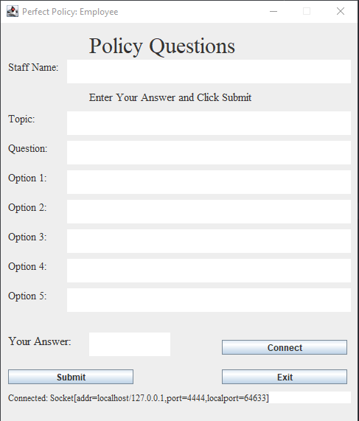 | Features by Component/Button  Connect button: Connects to server and allows the sending of quiz questions to user screen.  Submit button: Submits entered answer.  Exit button: Ends connection and closes client application.
How Do I?  Connect to the Server  - After opening the application, Click the Connect button.  - A message as shown in the picture should appear if the connection is successful. | How Do I?  Submit My Answers  - If a question is sent to you then the screen should autofill with the question and options.  - Firstly, fill out your name at the corresponding staff name text box.  - Input your answer to the text box next to the Your Answer label.  - Click Submit.

Evidence of correspondence with your Manager and Client

To: Mark O’Reilly
From: Oktay Turdu
CC:
BCC:
Date: 18/05/2022
Subject: Request for Program Specifications and Standards

-------------------------------------------------------------

Hi Mark O’Reilly

Regarding the Perfect Policies application, I request, to keep record, the exact Program Specifications and the Organisation’s Programming and Documentation Standards before commencing the project.

Regards,
Oktay Turdu

----------------------------------------------
Oktay Turdu
OktayTurdu@tafeqld.edu.eu.au
-----------------------------------------------

To: Mark O’Reilly
From: Oktay Turdu
CC:
BCC:
Date: 19/05/2022
Subject: Third-Party Library

-------------------------------------------------------------

Hi Mark O’Reilly

Regarding the Perfect Policies application, I propose the utilization of the Apache Commons String Utils Library. The reason being is that it contains methods and code that is both reusable for further expansion of the application in the future, and that these well-tested features will save time and development costs.

The licence can be located at https://www.apache.org/licenses/LICENSE-2.0. A copy has also been attached.

Regards,
Oktay Turdu

----------------------------------------------
Oktay Turdu
OktayTurdu@tafeqld.edu.eu.au
-----------------------------------------------

To: Perfect Policies
From: Oktay Turdu
CC:
BCC:
Date: 19/05/2022
Subject: Third-Party Library

-------------------------------------------------------------

Hi Perfect Policies

Regarding the Perfect Policies application, I propose the utilization of the Apache Commons String Utils Library. The reason being is that it contains methods and code that is both reusable for further expansion of the application in the future, and that these well-tested features will save time and development costs.

The licence can be located at https://www.apache.org/licenses/LICENSE-2.0. A copy has also been attached.

Regards,
Oktay Turdu

----------------------------------------------
Oktay Turdu
OktayTurdu@tafeqld.edu.eu.au
-----------------------------------------------

To: Mark O’Reilly
From: Oktay Turdu
CC:
BCC:
Date: 27/05/2022
Subject: Project Success and Suggestions

-------------------------------------------------------------

Hi Mark O’Reilly

Regarding the Perfect Policies application, the project has successfully been completed. Ongoing communication with the client is recommended to further business interests and expand on the application.

The application has a few minor bugs, as specified in the technical report, that are recommended to be fixed in a later iteration.

Regards,
Oktay Turdu

----------------------------------------------
Oktay Turdu
OktayTurdu@tafeqld.edu.eu.au
-----------------------------------------------

To: Perfect Policies
From: Oktay Turdu
CC:
BCC:
Date: 27/05/2022
Subject: Project Success and Suggestions

-------------------------------------------------------------

Hi Perfect Policies,

Regarding the Perfect Policies application, the project has successfully been completed. Ongoing communication is recommended to further your business interests and expand on the application.

The application has a few minor bugs, as specified in the technical report, that can be fixed if needed on a later iteration.

Regards,
Oktay Turdu

----------------------------------------------
Oktay Turdu
OktayTurdu@tafeqld.edu.eu.au
-----------------------------------------------

